**Name: ………………………………………………………… Date: ……………………………**

**Target mark: ………………**

**Comment about the topic……………………………………………………………………………..**

**BIOLOGY SELF EVALUATION TOPICAL TEST**

TOPIC: **NUTRITION IN PLANTS AND ANIMALS.**

**Time:** 1:30 minutes

**Item 1 (20 scores)**

During an investigation about nutrition in plants, students had an experiment conducted. A shoot of the hydrilla plant was placed in a boiling tube containing pond water. A bulb was also clamped **25cm** away from the boiling tube and the set up was connected to a syringe that would record the concentration of a certain **gas** after a given period of time. The **distance between the bulb and the boiling tube** was being adjusted bringing it closer to the set up and the syringe recording were also varying.

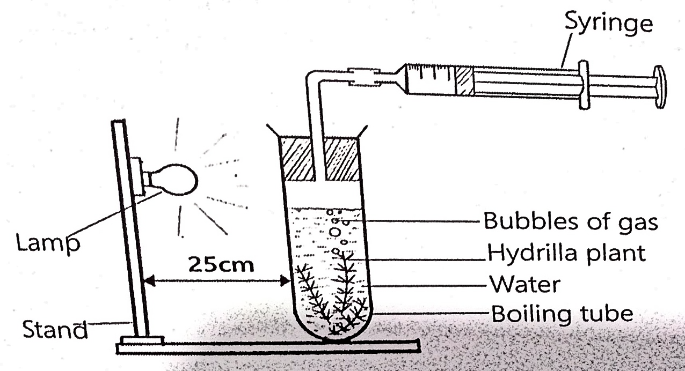

1. What was the aim of the investigation done by the students
2. Giving the expected results in the syringe and naming the gas being produced, explain the observations made
3. Explain other factors that would affect the rate of production of the gas named above
4. Explain how the structures responsible for food production on a plant are adapted to perform food production

**Item 2 (15 scores)**

Competitions were shifted from area A to area B due to the cloudy environmental conditions. Maxwell as one of the cyclists to compete, prior to the competition his pre-race meal was a mixture of a **heavy starchy** substance with a few pieces of **meat.** He expects this meal to enable him finish up the competitions efficiently. Area B is in a high-altitude mountain stage compared to Area A. Before he reached the finishing line he could not breathe well and had muscle twitches than would not enable him continue with the cycling. But later he breathed rapidly and was able to ride back home. He is wondering how his body is experiencing these conditions.

Task: prepare a written explanation you would send to maxwell explaining to him why and what changes took place in his body right after his pre-race meal until he went back home

**Item 3 (15 scores)**

With the ongoing war in DRC, most of the people that side have issues with attaining enough and quality food. The study is being done to solve the problem. Wazza ,19 years old with 45kgs and a height of 166cm was under a test in the hospital after his rescue. He had lost wait, poor appearance and so prone to infections. Wazza is in a new area and has lost the recommendation form given to him.

**Task:** As a learner who has studied nutrition, calculate his BMI and determine his class, explain the causes of his appearance, recommend to him a health eating life style and probe solutions to malnutrition in your community.

**End**